SYNOPSIS

Title: Pocket Journal- An AI Powered Diary Analyzer and Media Recommender

1. Introduction

In today’s fast-paced world, mental well-being often takes a backseat. People need tools that not only help them express how they feel but also understand those emotions in a deeper way. Pocket Journal is designed to do exactly that. It goes far beyond being just another diary app. It acts as a true wellness companion that helps users identify emotional patterns, gain insights into their mental state, and receive personalized suggestions to support their mood.

The app uses advanced Artificial Intelligence, combining modern Natural Language Processing models such as RoBERTa, BART, and Gemini. Together, these models analyze what the user writes, detect emotions, summarize thoughts, and provide meaningful feedback. The system also recommends mood-based content such as music, movies, or books, creating a complete ecosystem for reflection, understanding, and self-improvement.

2. Objectives
- To design a secure and user-friendly mobile application using Flutter, ensuring that user data and thoughts remain completely private.
- To develop an AI-based journaling system that can understand and interpret human emotions with high accuracy.
- To implement a multi-stage AI pipeline that includes BART for summarizing journal entries, RoBERTa for emotion detection, and Gemini for generating deep behavioral insights.
- To integrate personalized media recommendations using third-party APIs such as Spotify, Google Books, and TMDB.
- To build two interactive modules within the app the Wellness Dashboard for emotional insights and the Media Hub for personalized content suggestions.

3. Literature Survey

Text-based emotion detection has evolved from basic keyword and lexicon-based systems into highly intelligent models capable of understanding semantic and contextual meaning. Early methods were limited in recognizing emotional nuance, making them unsuitable for personal applications like Pocket Journal that must interpret informal, expressive writing.

Recent research highlights major progress in this field. The paper “Emotion Classification in Texts Over Graph Neural Networks: Semantic Representation is Better Than Syntactic” (Ameer et al., 2023) proved that semantic graph-based models outperform traditional approaches, showing that understanding relationships between words is more effective than relying on syntax alone. This finding supports Pocket Journal’s goal of analyzing user text semantically for deeper emotional insight.

Studies like “Emotion Recognition from WhatsApp Text Messages Using Unsupervised Machine Learning” (Padate et al., 2024) demonstrate that unsupervised methods such as Pointwise Mutual Information (PMI) can achieve over 92% precision on informal text, validating their use for unstructured and private user input. Similarly, “Personalized Emotion Detection from Text” (Goyal et al., 2022) introduced an adaptive model using Word2Vec and K-means clustering, capable of learning user-specific emotional patterns.

Together, these studies show that unsupervised and personalized emotion detection methods are more practical and scalable for private journaling. Pocket Journal builds on this foundation by combining semantic understanding, contextual analysis, and personalized recommendations—bridging emotional awareness with user well-being.

4. Proposed System

The proposed system, Pocket Journal, consists of two main modules: an AI Insight Engine and a Personalized Media Recommender. Both components work together to make journaling a guided and emotionally intelligent experience.

The AI Insight Engine: This is the main analytical unit of the system. When a user writes in the journal, the text is processed through a series of advanced AI models. The BART model performs abstractive summarization to shorten long entries while preserving their meaning. The summarized content is then passed to a fine-tuned RoBERTa model, which classifies the text into multiple emotion categories such as joy, sadness, anger, fear, and surprise. After classification, the Gemini 2.0 Flash large language model performs a deeper behavioral analysis to identify recurring emotions, personal goals, and patterns over time. These insights are displayed through an interactive Wellness Dashboard, helping users understand their emotional journey and overall mental state.

The Personalized Media Recommender: This module uses the results from the Insight Engine or the mood directly selected by the user to suggest personalized content. Based on the detected emotional state, it recommends books, podcasts, and music using external APIs such as Spotify, TMDB, and Google Books. The curated suggestions appear in the app’s Media Hub, offering supportive content aligned with the user’s emotions.
Together, the AI Insight Engine and the Personalized Media Recommender create a complete digital journaling ecosystem that not only understands user emotions but also provides meaningful ways to improve emotional well-being.

5. Methodology

Pocket Journal follows a client-server architecture with a Flutter-based mobile front end and a Python Flask backend. User entries are stored securely in Google Firestore and processed through a multi-stage AI pipeline.

When a user writes in the journal, the text is first pre-processed to remove noise and normalize structure. The BART model then performs abstractive summarization, condensing long entries into meaningful summaries. The summarized text is analysed by the RoBERTa model for multi-class emotion detection, identifying emotions such as joy, sadness, anger, and fear.

The Gemini 2.0 Flash model performs deeper behavioural analysis, identifying emotional trends, recurring thoughts, and goals across selected time periods. These insights are displayed in a Wellness Dashboard, giving users a visual overview of their emotional state.

Based on the detected emotions, the Personalized Media Recommender uses APIs such as Spotify, Google Books, and TMDB to suggest relevant media. All user data is encrypted, ensuring privacy and secure storage.

6. Block Diagram

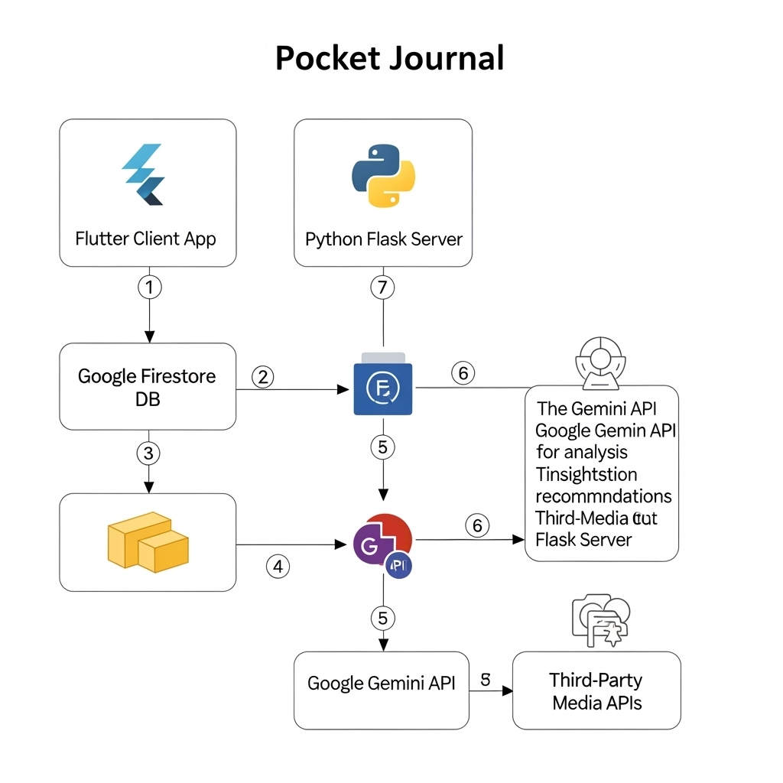

7. Hardware & Software Requirements

Hardware Requirements:
Pocket Journal is designed to run on standard consumer devices without specialized hardware.

Smartphone with Android or iOS support

Minimum 4 GB RAM and 64 GB storage

Internet connectivity for cloud-based processing

Software Requirements:
The system uses a combination of modern development and AI technologies for performance and scalability.

Frontend: Flutter SDK with Dart

Backend: Python Flask framework

Database: Google Firestore for secure data storage

AI Models: BART for summarization, RoBERTa for emotion classification, Gemini 2.0 Flash for behavioral insights

APIs: Spotify, Google Books, and TMDB for personalized media recommendations

Cloud Platform: Google Cloud or AWS for hosting and model deployment

8. Expected Outcome
At the end of this project, we will have a fully functional and refined mobile application called Pocket Journal.

This app will offer two core features:
- A Wellness Dashboard that provides users with a detailed and insightful breakdown of their emotions over time.
- A Media Hub that delivers a personalized and continuously updated feed of supportive content such as books, podcasts, and music.
- The application will help users not only recognize and understand their emotions but also discover healthy, constructive ways to manage and improve their mental well-being.

9. Applications

Personal Wellness: A great daily tool for anyone who wants to understand their emotions better and improve their mental well-being.

Mood Regulation: Actively helps users find content that can positively influence their mood.

Mindful Content Discovery: Provides a healthier alternative to endless scrolling by suggesting content that is genuinely relevant to the user's current emotional state.

Support for Therapy: A fantastic aid for therapy, allowing users to track emotional patterns and discover resources that supplement their sessions.

10. Conclusion

Pocket Journal redefines digital journaling by combining emotional intelligence with advanced AI technology. Through its multi-model analysis using BART, RoBERTa, and Gemini 2.0 Flash, the system transforms simple text entries into meaningful emotional insights and personalized recommendations. With its Wellness Dashboard and Media Hub, the app not only helps users understand their emotions but also guides them toward positive self-growth and mental well-being.

11. References

Books & Research Papers:
[1] I. Ameer, N. Bölücü, G. Sidorov, and B. Can, “Emotion Classification in Texts Over Graph Neural Networks: Semantic Representation is Better Than Syntactic,” IEEE Access, vol. 11, pp. 56921–56934, May 2023, doi: 10.1109/ACCESS.2023.3281544.
[2] H. Gunjal, T. Kharde, A. Nair, T. Sase, and Y. Sisodia, “Emotion Based Music and Movie Recommendation System Using Python,” Int. J. Current Science (IJCSPUB), vol. 13, no. 2, pp. 415 422, Apr. 2023.
[3] S. Challa, N. P., G. Manohari V., D. D. Clemency C. A., and R. M. S., “Content Recommendation Based on Recognised Emotion,” in Proc. 2023 Int. Conf. Recent Adv. Electr., Electron., Ubiquitous Commun., Comput. Intell. (RAEEUCCI), 2023, pp. 1–6, doi: 10.1109/RAEEUCCI57140.2023.10134505.
[4] J. K. Leung, I. Griva, and W. G. Kennedy, “Text-Based Emotion Aware Recommender,” in Proc. CS & IT - CSCP, 2020, pp. 101–114, doi: 10.5121/csit.2020.101009.
[5] J. Mizgajski and M. Morzy, “Affective Recommender Systems in Online News Industry: How Emotions Influence Reading Choices,” User Modeling and User-Adapted Interaction, vol. 29, pp. 345 379, 2019, doi: 10.1007/s11257-018-9213-x.
[6] S. Unnisa and A. N. S., “Personalized Mood-Centric Book Recommendation Integrating Machine Learning with Content Based Filtering,” Int. J. Inf. Technol., Res. Appl. (IJITRA), vol. 3, no. 3, pp. 15 22, Sep. 2024, doi: 10.59461/ijitra.v3i3.100.
[7] T.-Y. Kim, H. Ko, S.-H. Kim, and H.-D. Kim, “Modeling of Recommendation System Based on Emotional Information and Collaborative Filtering,” Sensors, vol. 21, no. 6, p. 1997, Mar. 2021, doi: 10.3390/s21061997.
[8] N. Krishnakumar, M. K. K., N. A. R., M. N. S., and S. E. T., “Mood-Based Recommender: Music and Book Recommendations,” Int. J. Novel Res. Dev. (IJNRD), vol. 9, no. 5, pp. a737–a743, May 2024.
[9] N. Tennakoon, O. Senaweera, and H. A. S. G. Dharmarathne, “Emotion-Based Movie Recommendation System,” Int. J. Adv. ICT Emerg. Regions, vol. 17, no. 1, pp. 35–39, 2024, doi: 10.4038/icter.v17i1.7275.

Web References & Technical Articles:

Google Gemini API Documentation. (https://ai.google.dev/docs)

Hugging Face Transformers. (https://huggingface.co/docs/transformers)

Flutter Official Documentation. (https://flutter.dev/)

Flask Web Framework. (https://flask.palletsprojects.com/)

Google Firestore Documentation. (https://firebase.google.com/docs/firestore)

